Ei Thinzar Naing (231006002)
ITE355 Final Project
Final Project Report

Table of Contents

Table of Contents 1
Introduction 2
Case: AI and IT Skill Co-occurrence Analysis using FP-Growth Association Mining on LinkedIn Job Postings Data 3
Data Description and Preparation (ETL) 3
Methods – Association Data Mining 8
Output (Visualization) 10
Results Discussion 10
Limitations 11
Conclusion 11
References 12

Introduction

AI is changing many jobs in the tech industry, but not all IT roles are affected the same way. Roles like “AI Engineer” or “Data Scientist” obviously need AI skills, but what about more traditional roles, like Network Engineer or Software Engineer? Are these jobs starting to require AI skills too?
This report answers the question: “How does the co-occurrence between AI/ML skills and traditional IT skills in job postings vary across different IT job roles, and which non-AI IT job roles are being reshaped the most by AI adoption?”
To answer this, I used Association Rule Mining (FP-Growth) on a large set of real job postings from LinkedIn. This technique finds which skills tend to appear together in the same job posting, helping us see how deeply AI has spread into each type of IT job.
This report is written for an L&D (Learning & Development) Manager, who decides which teams should get AI training first. Instead of guessing, this report uses real job market data to show exactly which IT roles need AI training the most right now.

Case: AI and IT Skill Co-occurrence Analysis using FP-Growth Association Mining on LinkedIn Job Postings Data

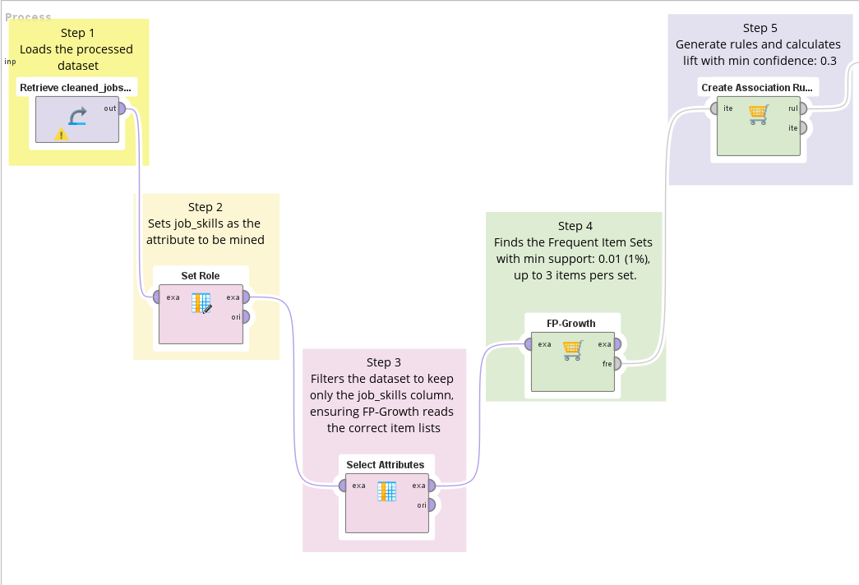

Data Description and Preparation (ETL)
The dataset consists of two linked files, “linkedin_job_postings.csv” & “job_skills.csv”, sourced from Kaggle. The raw data contained over 1.3 million job postings scraped from LinkedIn, spanning all industries, with skills listed as unstructured comma-separated text and job titles requiring significant filtering to isolate IT-specific roles.

First Dataset
Second Dataset

The primary challenge was consolidating two large, separately scraped files into one clean, industry-specific, analysis-ready dataset.
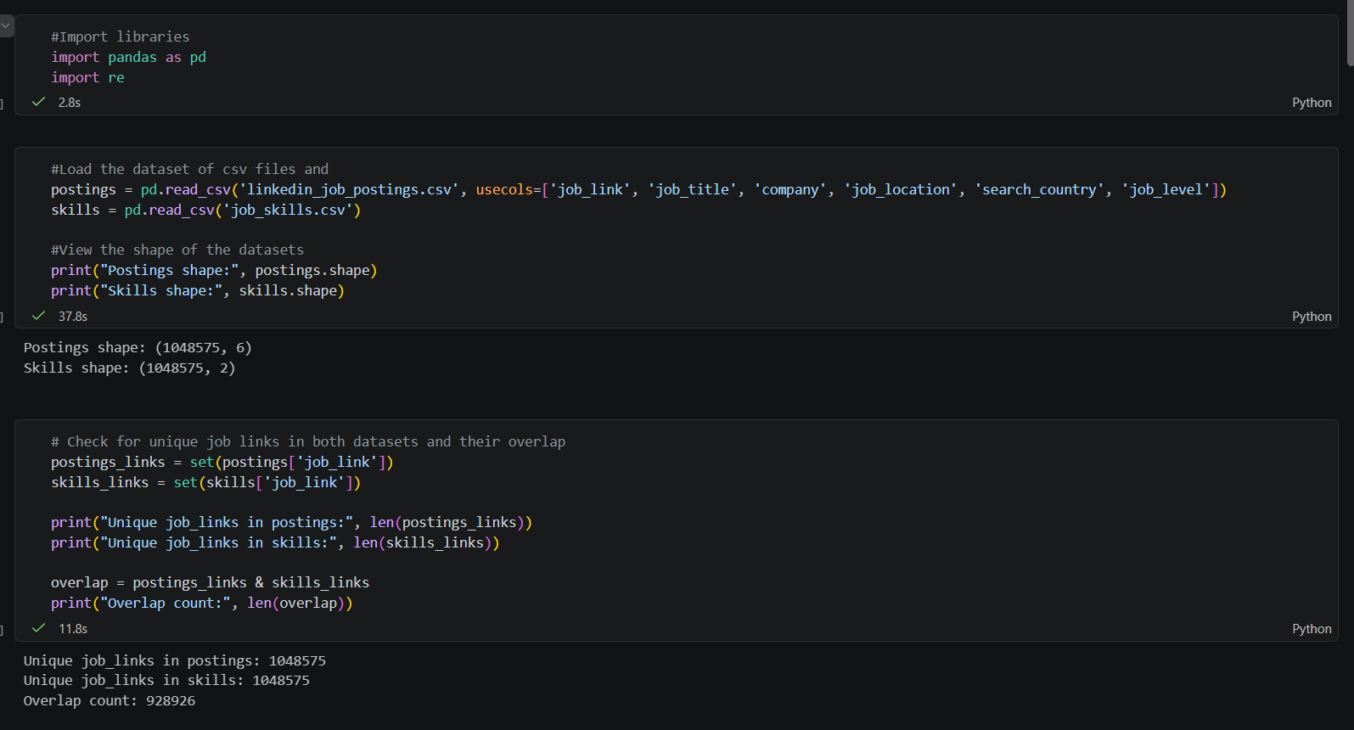

Data Integration: The pandas.merge( ) function was used to join two datasets on the shared job_link key, combining job title, location, company data with each posting’s required skills into a single data frame of 928,926 matched records.
Data Reduction: A .str.contains( ) regex filter was applied to job_title column using a list of IT-specific keywords (e.g., “software engineer”, “data analyst”) for reducing the dataset from all industries. Exclusion terms were also applied to remove false positives from unrelated fields.
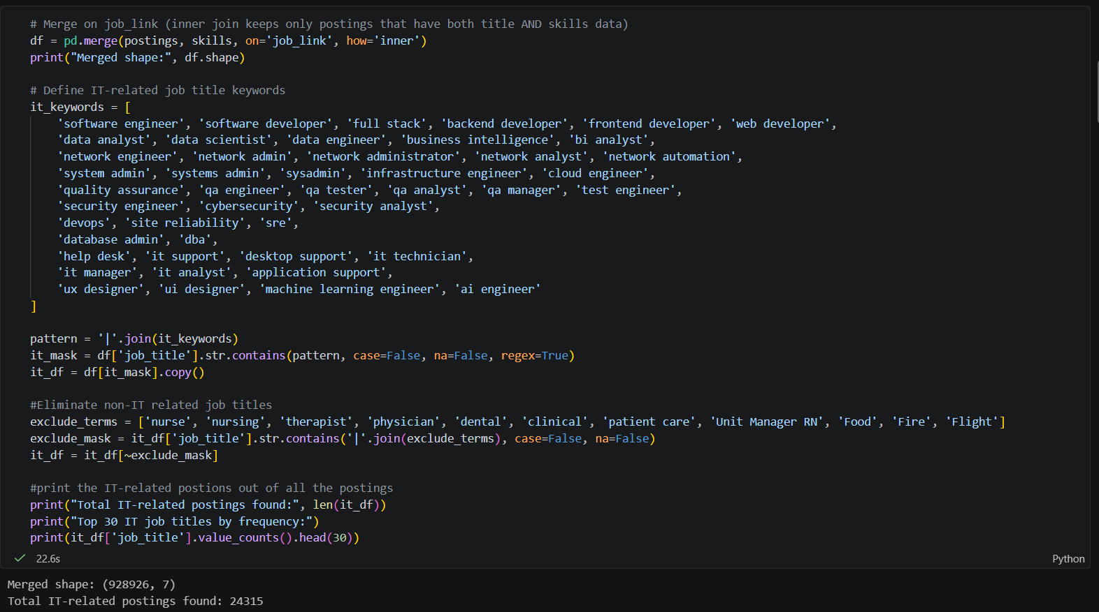

Data Transformation (Categorization): A custom Python function mapped each of the many raw job title variants (e.g., “Senior Software Engineer”, “Lead Software Engineer”) into 19 consolidated job role categories using keyword-based logic, enabling consistent comparison across roles.
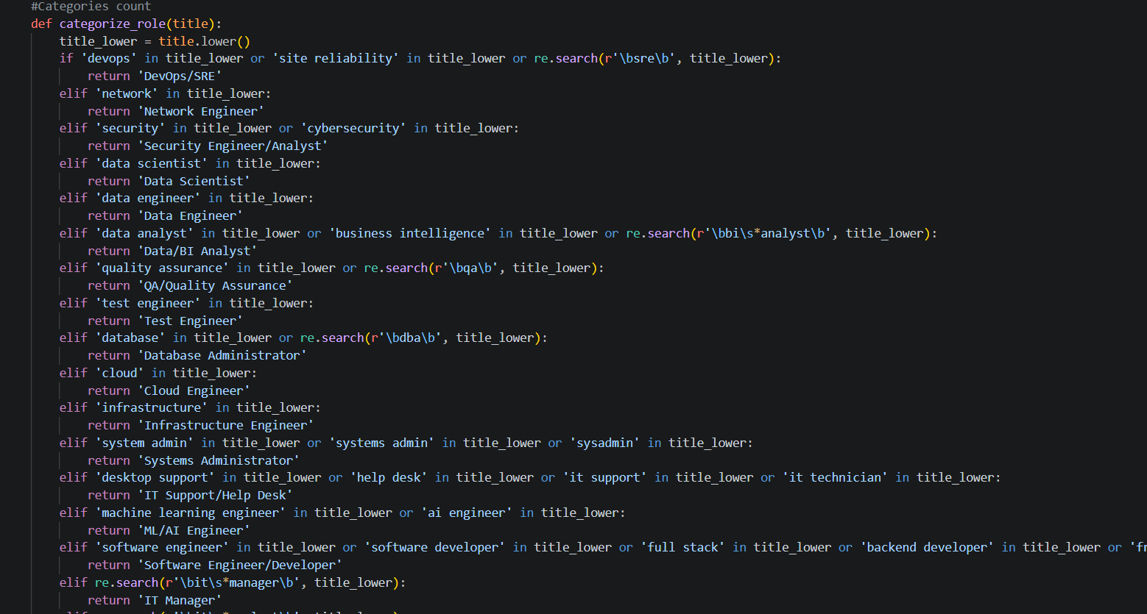
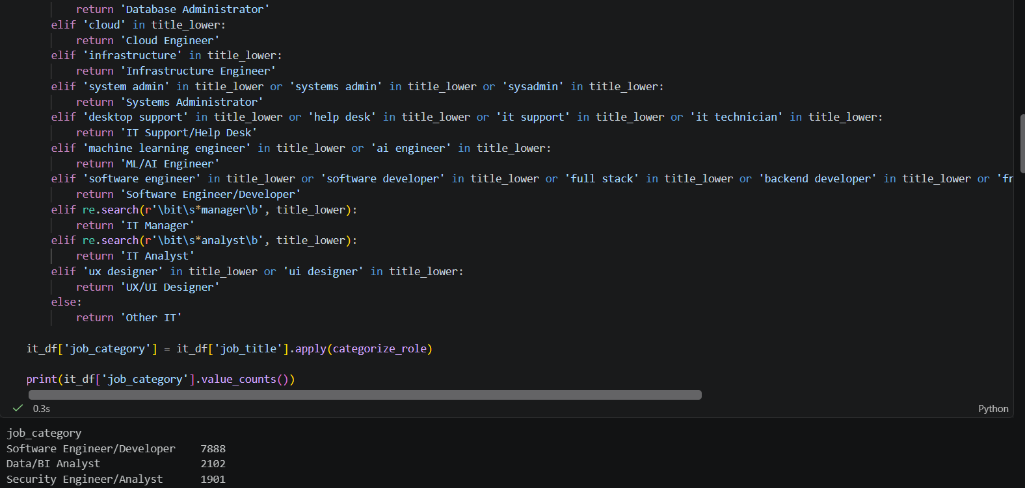

Data Transformation (List Conversion): The job_skills column, originally a single comma-separated text string per posting, was split into a Python list of individual skills using str.split(‘,’). It produces the item format required for association rule mining.
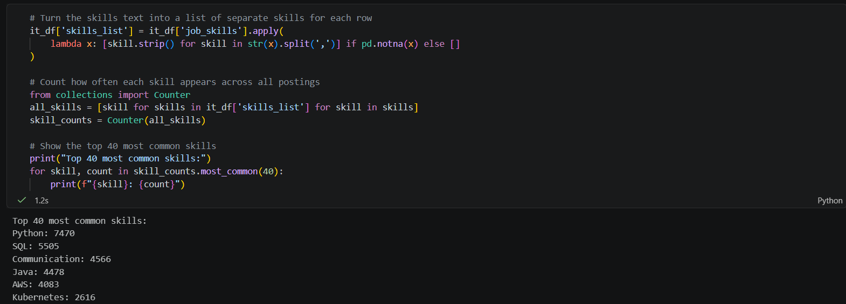

Data Discretization (AI Tagging): Each individual skill was labeled as either AI-related or Traditional by matching against a keyword dictionary (e.g., “machine learning”), and each posting was flagged with a has_ai_skill Boolean based on whether any AI-related skill was present.
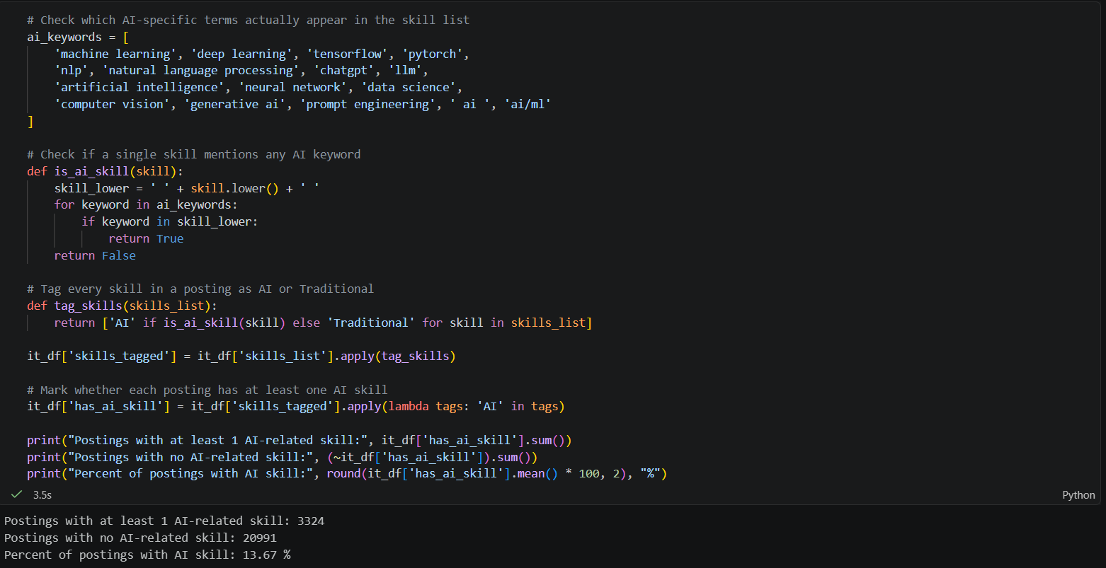
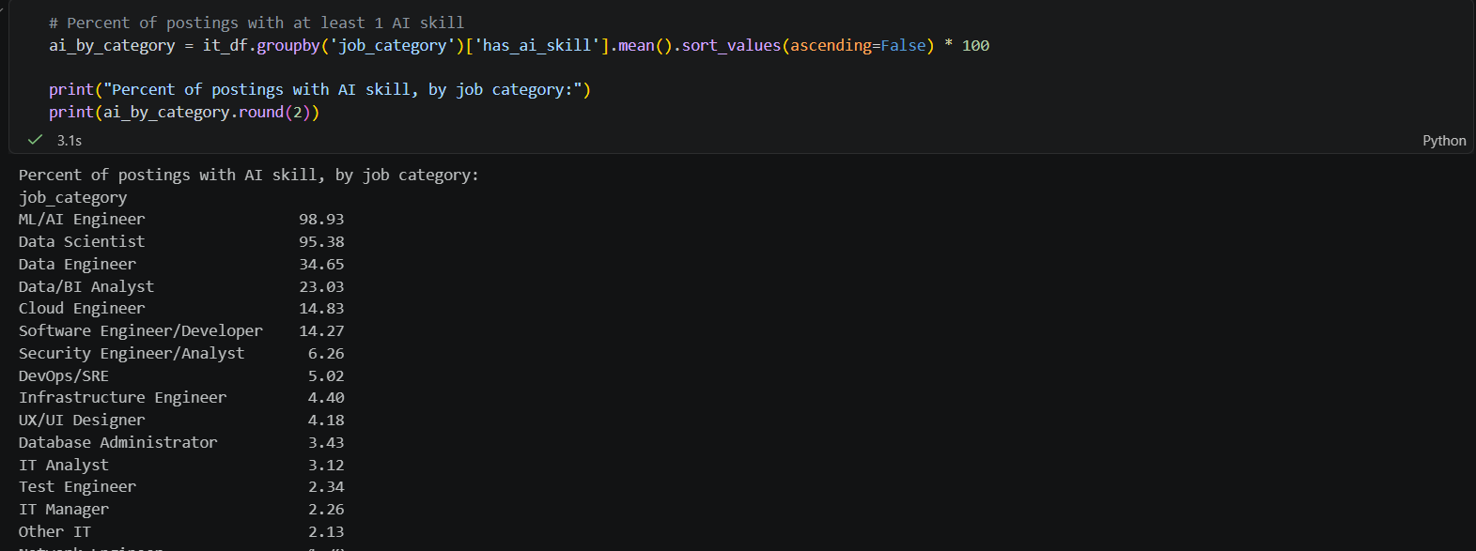

Data Cleaning: Postings with an empty skills list after splitting were removed and stray double-quoted characters within text fields were stripped of file-parsing errors.
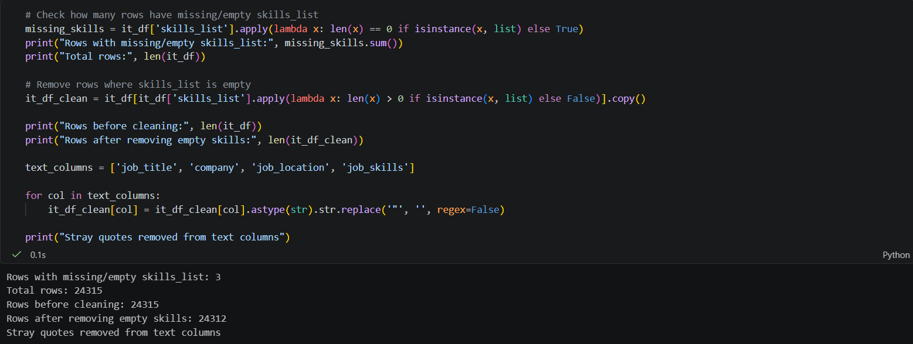
Export: The final processed dataset was exported and is ready to be imported into AI studio for the data mining phase.
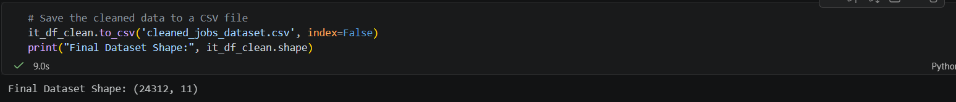

Methods – Association Data Mining
Process Setup
Step 1 (Retrieve): Loads the processed dataset that was exported from the Python ETL.
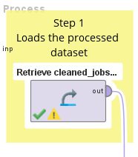
Step 2 (Set Role): Sets job_skills as the attribute to be mined, setting it as the target column for the association rule algorithm.
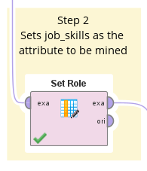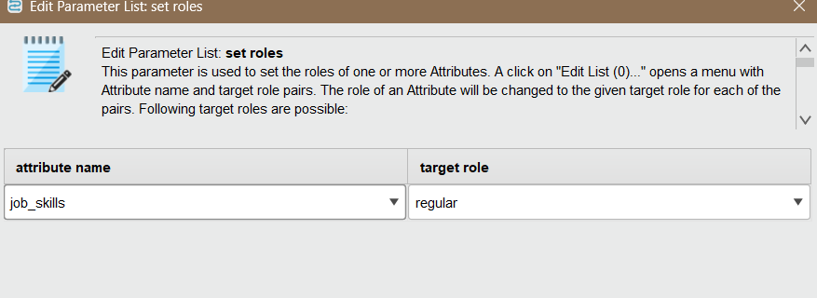
Step 3 (Select Attributes): Filters the dataset to keep only the job_skills column, ensuring FP-Growth reads the correct item list.
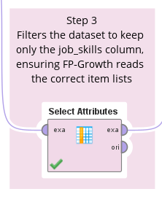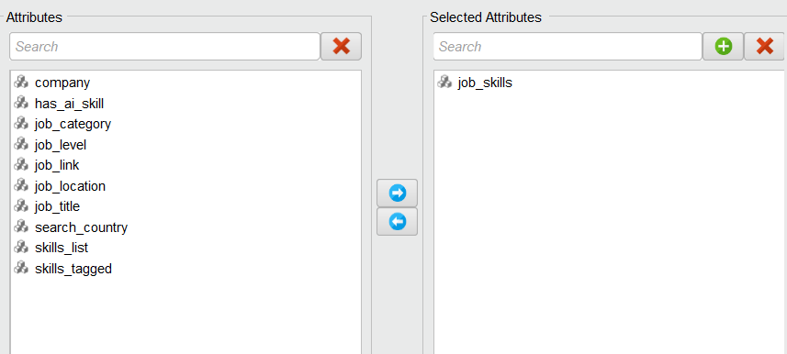
Technique: The Association Mining technique was used via the FP-Growth algorithm. FP-Growth efficiently identifies frequent item sets without needing to generate all possible combinations.
Step 4 (FP-Growth): Found the Frequent Item Sets. The Min Support was set to 0.01 to capture meaningful skill co-occurrence patterns without overwhelming the system, and item sets were capped at a maximum of 3 items pers set, resulting in 1,525 frequent item sets.
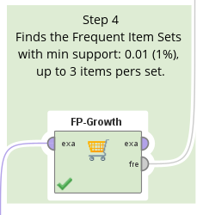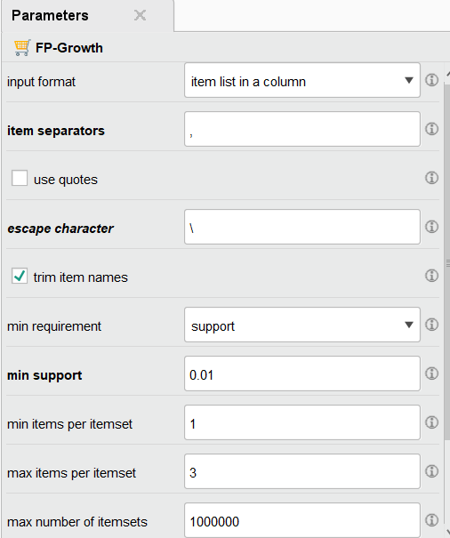
Step 5 (Create Association Rule): Generated the actionable rules and calculated Lift and Confidence. The Min Confidence was set to 0.3, with gain theta set to 2.0 and Laplace k set to 1.0 as default smoothing parameters.
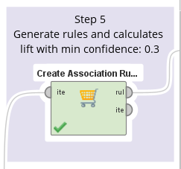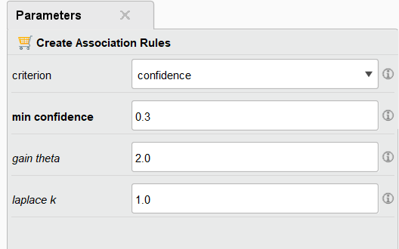

Output (Visualization)
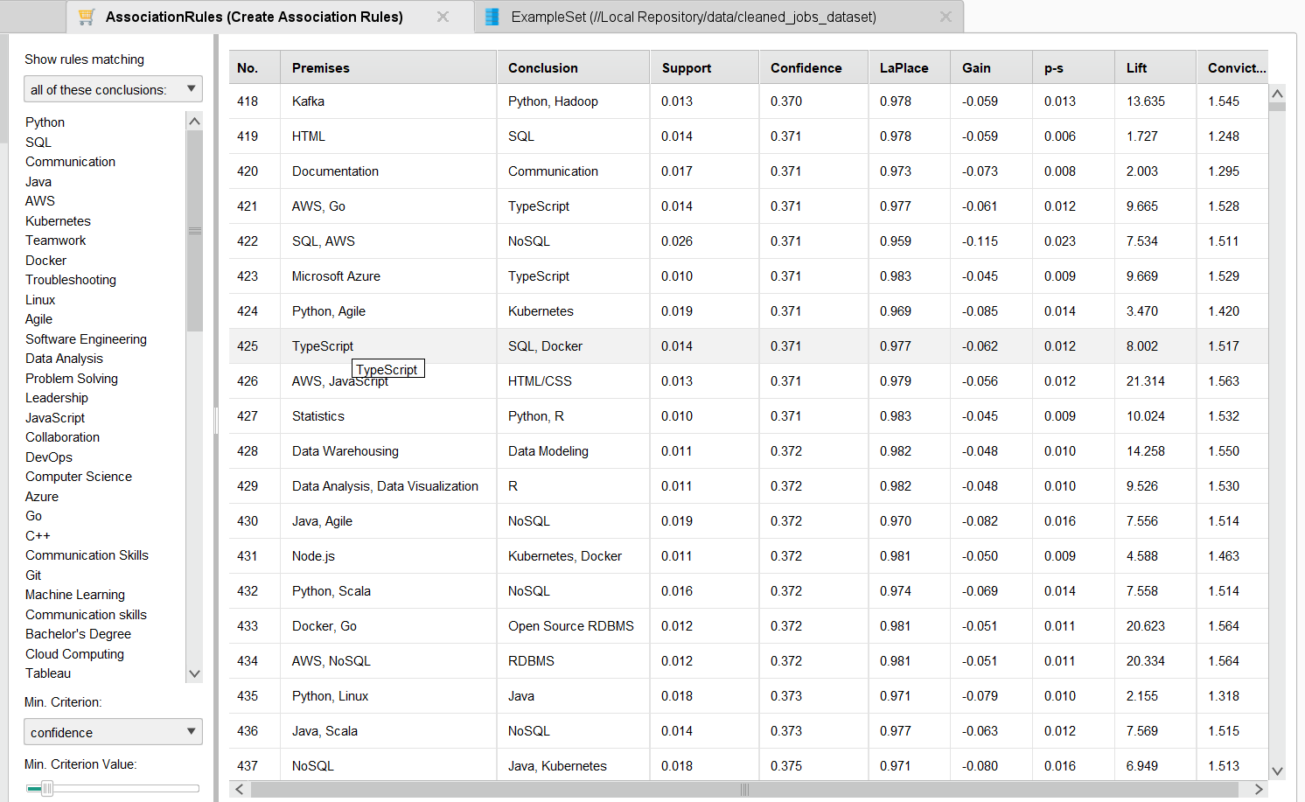

Results Discussion
Rule Interpretation: The rule [Artificial Intelligence] [Machine Learning] confirms these two AI skills are treated as a paired requirement, not standalone. High-Lift infrastructure rules (eg., [AWS, NoSQL] RDBMS also established technology stacks appearing far more often together than random chance would predict.
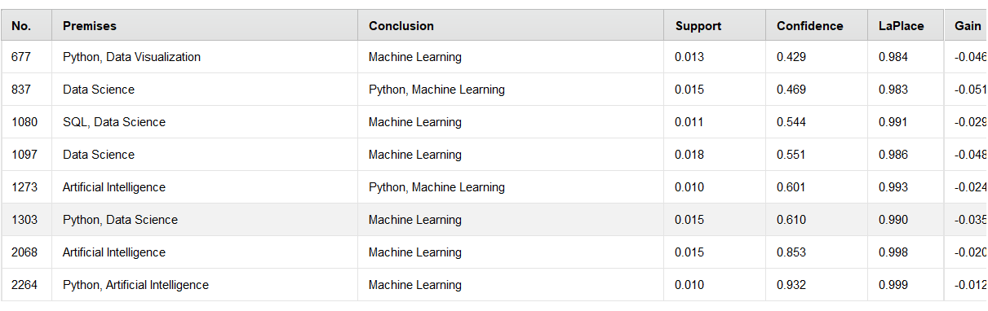
Cross-referencing with the job-category breakdown, Data Engineer (34.65% AI skill presence) and Data/BI Analyst (23.90%) are the non-AI titled roles most strongly associated with AI adoption and Network Engineer (1.70%) or Systems Administrator (1.22%) with least AI adoption.
Business Recommendation: The L&D Manager (Learning and development) should prioritize AI upskilling investment as follows:
- Prioritize AI upskilling budget for Data Engineering and Data/BI Analyst teams first.
- Bundle training around skills shown to co-occur strongly (e.g., Python + Machine Learning).
- Monitor lower-adoption roles (Network Engineer, IT support) to plan future upskilling phases.

Limitations
- Single time snapshot: The dataset covers 2024 only, so this report shows current AI-skill association by role, not how fast it's changing over time.
- Title-based categorization: Roles were grouped using keywords matching on job titles, which may still misclassify some ambiguous postings.
- Self-reported skills: Skill lists reflect what employers chose to write, not necessarily the full real-world requirements.
- LinkedIn-only data: Results may not represent smaller companies or job markets outside LinkedIn.

Conclusion
This project used Association Rule Mining to study over 24,000 IT job postings and find out how AI skills connect with traditional IT skills. The results show that AI is not spreading equally across all IT jobs.
As expected, roles like Data Scientist and AI/ML Engineer almost always require AI skills. But more importantly, among traditional, non-AI job titles, Data Engineer (34.65%) and Data/BI Analyst (23.90%) stood out as the roles most connected to AI, much higher than roles like Network Engineer or Systems Administrator, which barely show any AI skill requirements yet.
I also found strong patterns like {Artificial Intelligence} → {Machine Learning}, appearing together 85.3% of the time, showing that AI skills are usually required as a group, not one at a time.
For the L&D Manager, this means Data Engineering and Data/BI Analyst teams should get AI training first, since the job market already expects them to have these skills. Training programs should also bring group related skills together (like Python with Machine Learning), since that's how employers ask for them. Other IT teams, like Network Engineers, can be trained later, once AI adoption spreads further into those roles. Overall, this project shows how a simple data mining technique can turn a big, vague question ("is AI changing IT jobs?") into a clear, specific action plan for a company's training strategy.

References
AI studio academic hub. (2023). Altair.Com. https://web.altair.com/academic-hub-ai-studio
asaniczka. (2024). 1.3M linkedin Jobs & Skills (2024). Kaggle.Com. https://www.kaggle.com/datasets/asaniczka/1-3m-linkedin-jobs-and-skills-2024
Claude. (2026). Claude. https://claude.com/
Microsoft. (2025). Visual studio code. Microsoft. Visualstudio.Com. https://code.visualstudio.com/

